**Blog 1**

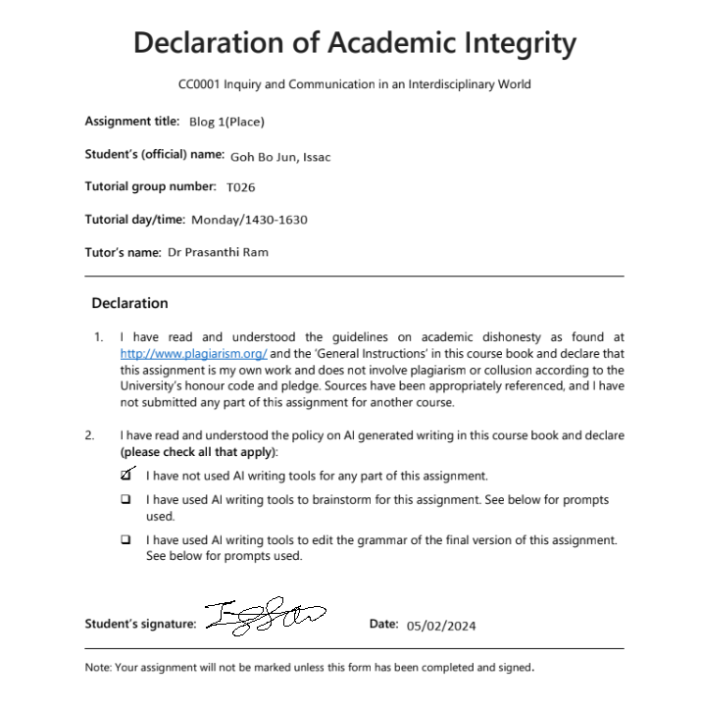

| ***Chosen topic: Place, Boruda Climbing Gym*** |
| --- |
| ***Field notes***   * *Chalk in air, benches and tables,colourful climbing holds on wooden walls, people working on laptops,loud cheers of encouragement, tidy shoe rack but floor with messy slippers, ping-pong table, training area,sound of crashing people on crash pads, bright lighting focused on walls*   ***Additional material*** |

| **General Os**  *Write the introduction (3-4 lines) to your op-ed using the general observations you have underlined. Consider how you would introduce your reader to your chosen topic.* | | | |
| --- | --- | --- | --- |
| Tucked away in a corner of Singapore sits a small Japanese inspired climbing gym, Boruda. As I stepped into the gym, I was greeted by a plethora of colourful climbing holds snaking up the bland wooden walls. The chalked filled air seemingly impedes my vision, reminding me of the annual haze, while the cool breeze of the air conditioning dances around me. As my sense of hearing heightens to compensate for my reduced visibility, audible cheers could be heard coming from the cluster of people gathered near the crash pads beneath the walls. | | | |
| **Significant O**  *Describe your significant observation(s) in complete sentences: 1 significant detail or anomaly, 2 details that contrast each other 2-3 details that work as a pattern. If you are not sure which significant O to pick and would like my advice, you can fill out O1 and O2. Otherwise, just O1 is acceptable.* | | **Reflect**  *What questions did this O spark in you?* | **Analysis**  . *Answer your reflection questions* |
| **O1** | *Lined along one side of the gym was a row of wooden benches and tables, presently occupied by adults in their early 20s. Their brows are furrowed in deep concentration as they furiously type away at the laptop,presumably for their work or studies. One would assume that they came here solely to work in an air-conditioned environment. Yet,on the contrary , their climbing shoes remain tightly laced, also showcasing their unwillingness to be off the wall. The silence was deafening and painfully obvious compared to the mere two metres away gap where climbers' cheers filled the room as someone was making their way up the wall. The adults' poor hunched up posture while working was made even more apparent when contrasting with some of the climbers blatantly lounging on the floor as if it were their own home.* | What are some assumptions I had prior to this O? (Self)  What do I think has caused this? (Conceptual) | *I could not have foreseen that people would bring their work life into their hobbies as I hold the belief that hobbies are a form of activity to help break free from the working environment and to destress. Furthermore, I assumed that the benches there were to be used when consuming meals as the signs there denoted that meals were restricted to the tables. The climbers have thus utilised it for a completely different purpose seemingly due to their inability to break free from the clasp of the working world.  I think that such a scene has unfolded due to the competitive nature of Singapore society. From early schooling, students in Singapore are taught to be the best. The education system has thus had a long term opportunity to ingrain into all the concepts of hard work at the expense of all else.* |
| *Distil 2 concepts that are related to your chosen detail(s).* | | *Work-life balance and rat-race* | |